Assignment 01

Algorithms & Data Structures

Due Date: October 12, 2015

Question 1: Analyse the following programs and compute Big-oh complexity.

(i)

x =0;

for(i=1; i<=n; i=i*3)

{

if(i%2 != 0)

for(j=0; j<i; j++)

x++;

}

(ii)

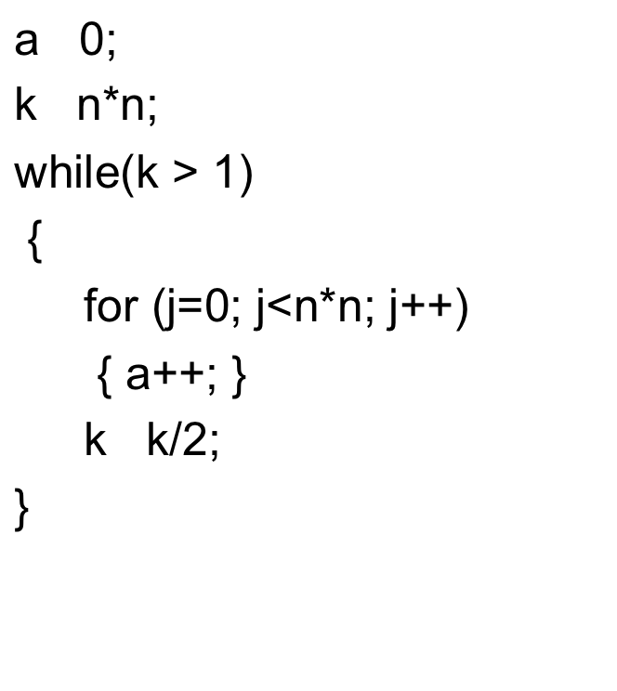

(iii)

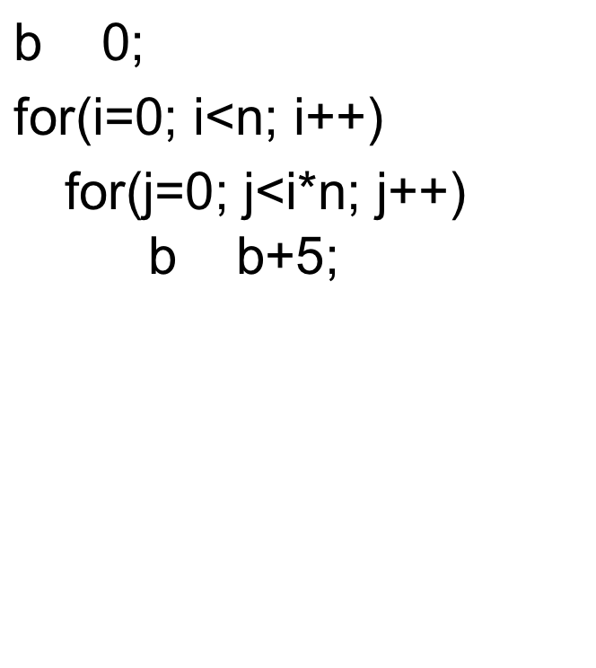

(iv)

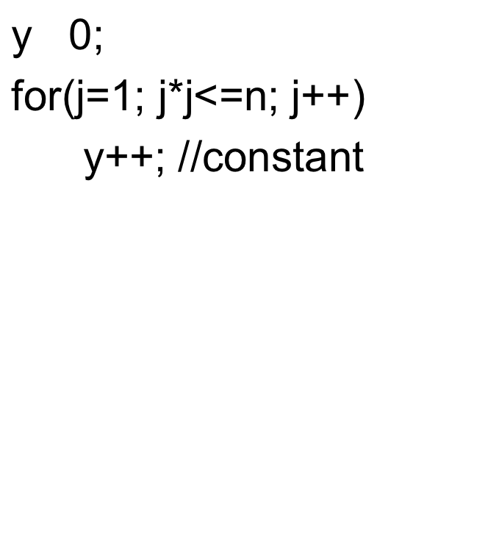

(v)

Question 2: Write recurrence relation of the following algorithm and solve using Backward substitution method:

## (i)

fibonacci(n)

{

if (n == 0 || n == 1)

return 1;

else

return fibonacci(n - 1) + fibonacci(n - 2);

}

(ii)

funct(n)

    if n == 1 return

    else

       funct(n/2)

       funct(n/2)

       funct(n/2)

       funct(n/2)

       for(i=1; i<=n; i++) print i;

       return